2025-09-30

Trees (Solutions)

Exercises
- Consider the following tree:
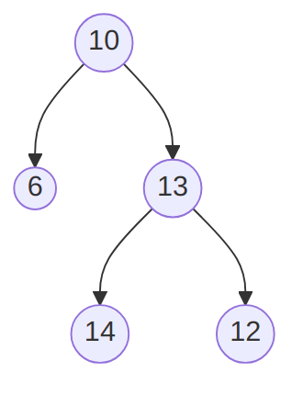
A binary tree that is not a binary search tree. (text version, image version, svg version)
  - Explain why it is not a binary search tree.
Solution
The left child of the node with value 13 has value 14, which is greater than 13, hence violating the binary search tree principle that values in the left sub-tree should be strictly less than the value in the root of the subtree. The same goes for 12.
  - Pick one among inorder, preorder and postorder traversal, and give
    - A brief description of how it proceeds,
Solution
One among the following:
      - Inorder traversal processes (recursively) first the left subtree, then the data at the root, then the right subtree.
      - Preorder traversal processes (recursively) first the data at the root, then the left subtree, then the right subtree.
      - Postorder traversal processes (recursively) first the left subtree, then the right subtree, then the data at the root.
    - What it would produce for the given tree.
Solution
One among the following:
      - Inorder gives 6, 10, 14, 13, 12
      - Preorder gives 10, 6, 13, 14, 12
      - Postorder gives 6, 14, 12, 13, 10
- Consider the following implementation of “random” binary trees:
public class RBTree<T>
{

private class Node
{
public T Data { get; set; }
public Node left;
public Node right;
public Node(
T dataP = default(T),
Node leftP = null,
Node rightP = null
)
{
Data = dataP;
left = leftP;
right = rightP;
}
}

private Node root;

public RBTree()
{
root = null;
}

public void Insert(T dataP)
{
root = Insert(dataP, root);
}

private Node Insert(T dataP, Node nodeP)
{
if (nodeP == null)
{
return new Node(dataP, null, null);
}
else
{
Random gen = new Random();
if(gen.NextDouble() > 0.5)
{
nodeP.left = Insert(dataP, nodeP.left);
}
else
{
nodeP.right = Insert(dataP, nodeP.right);
}
}
return nodeP;
}
}
Note that the Insert(T dataP, Node nodeP) method uses the gen.NextDouble() > 0.5 test that will be randomly true half of the time, and false the other half.
  - Explain the T dataP = default(T) part of the Node constructor.
Solution
This makes the first argument of the constructor optional: if no value is provided, then the default value for T is used. For example, for int, then 0 would be used.
  - Write a ToString method for the Node class, remembering that only a node Data needs to be part of the string returned.
Solution
public override string ToString()
{
return Data.ToString();
}
  - Write a series of statements that would
    - create a RBTree object,
    - insert the values 1, 2, 3, and 4 in it (in this order).
Solution
RBTree<int> btree = new RBTree<int>();
btree.Insert(1);
btree.Insert(2);
btree.Insert(3);
btree.Insert(4);
  - Make a drawing of a possible RBTree obtained by executing your code.
Solution
Any binary tree containing 1, 2, 3 and 4, with 1 at the root, 2 a child of 1, 3 a child of 1 or 2, and 4 a child of 1, 2 or 3, is correct. One such example is:
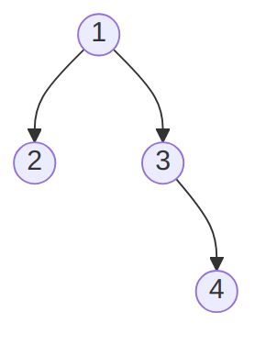
The “random” binary tree obtained by inserting 1, 2, 3 and 4 (in that order). (text version, image version, svg version)
  - Write a Find method that takes one argument dataP of type T and returns true if dataP is in the RBtree calling object, false otherwise.
Solution
public bool Find(T dataP)
{
bool found = false;
if (root != null)
{
found = Find(root, dataP);
}
return found;
}

private bool Find(Node nodeP, T dataP)
{
bool found = false;
if (nodeP != null)
{
if (nodeP.Data.Equals(dataP))
{
found = true;
}
else
{
found =
Find(nodeP.left, dataP)
|| Find(nodeP.right, dataP);
}
}
return found;
}

