2025-03-11

# Description

## Purpose

This project is designed to teach you how to interpret and implement a simple UML specification involving multiple classes. It involves inheritance, polymorphism, properties and exception handling.

## Challenge

### In short

Develop multiple classes to represent animal taxonomy. Different animal species have different characteristics—for example, species that belongs to the mammal class will have mammal glands—but they also all share some common properties, like their conservation status or estimated population. You need to develop at the same time a system to capture the similarities across species, and to be able to represent relevant attributes and characteristics for each species.

### In more details

We want to implement the classes pictured in the UML diagram (you right click and select “Open Image in New Tab”, or access the other versions listed in caption).

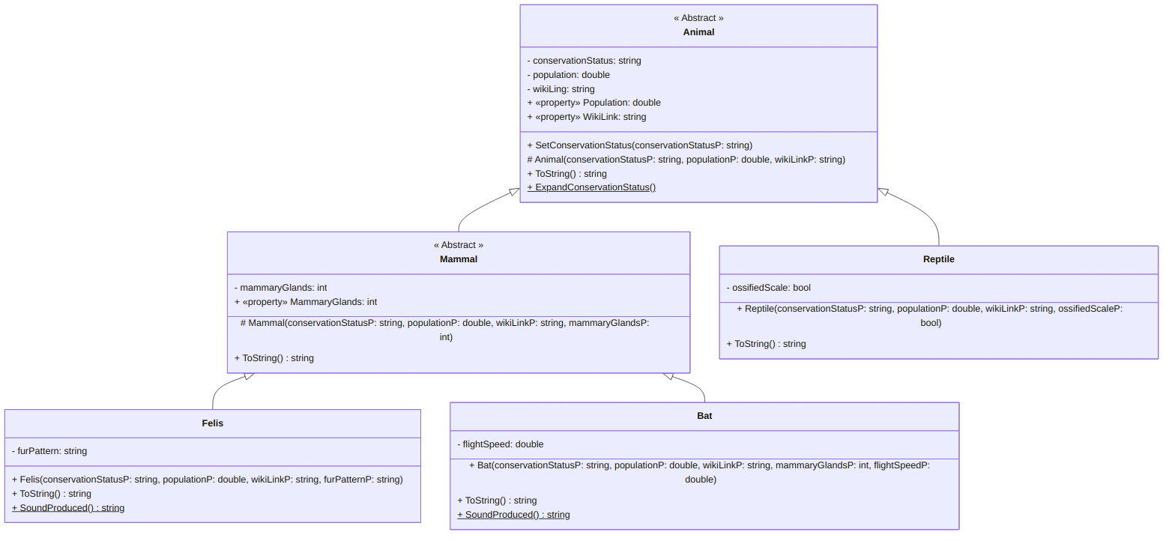

A UML diagram for the Animal ⇽ Mammal class ([text version](https:/princomp.github.io/uml/cla/Species.txt), [image version](https:/princomp.github.io/uml/cla/Species.png), [svg version](https:/princomp.github.io/uml/cla/Species.svg))

Keeping in mind that:

* Static methods are u͟n͟d͟e͟r͟l͟i͟n͟e͟d͟,
* The constructors in the Animal and Mammal classes are *protected* (that is the # sign): simply declare them using
* protected Animal(string conservationStatusP, double populationP, string wikiLinkP){…}

**Pay attention to details**, and note that

* Population is represented with a double as it represents *thousands* of individuals.
* The constructor for Felis does not require a mammaryGlandsP parameter, since all felis have 8 mammary glands. Bats, [however](https://www.auburn.edu/cosam/faculty/biology/hood/lab/documents/Kunz.et.al.2010.LactationChapter.pdf), can have a varying number of mammary glands.

In addition, you code should be such that:

* The characters for the conservationStatus should be [one of the IUCN Red List of Threatened Species](https://en.wikipedia.org/wiki/Conservation_status#IUCN_Red_List_of_Threatened_Species) code: EX, EW, CR, EN, VU, NT, CD, LC, DD, or NE. Your SetConservationStatus method should throw an exception if any other value is passed, and your Animal constructor should call the SetConservationStatus method.
* An exception should be thrown if Population is greater than $0$ and conservationStatus is set to EX (which stands for Extinct). An exception should also be thrown for negative values, except if conservationStatus is set to DD (data deficient).
* An exception will be raised if the url for the WikiLink property does not start with https://en.wikipedia.org/wiki/.
* MammaryGlands should not accept any value not listed at <https://en.wikipedia.org/wiki/Mammary_gland#General> under “Total”.
* For Felis and Bat, the SoundProduced methods should simply return a string containing “mew, meow, purr, hiss, trill, caterwaul, growl” and “screech, squeak, eek”, respectively ([source](https://en.wikipedia.org/wiki/List_of_animal_sounds)).
* A Bat flight speed cannot be negative, but it can be $0$ (which is used for “unknown”).
* The ExpandConservationStatus method should expand the abbreviations of conservationStatus (as given e.g., at <https://en.wikipedia.org/wiki/Conservation_status#IUCN_Red_List_of_Threatened_Species> and below) and give a short definition.
* For each relevant class, the ToString method should display all the attributes and properties.

Your code should be such that the following[1]:

using System;  
  
class Program  
{  
 static void Main()  
 {  
 // Helper string, to display more nicely  
 string sep = "\n\n" + new String('*', 20) + "\n\n";  
  
 /*  
 * The following are given as indications that  
 * both Animal and Mammal should be implemented as  
 * abstract classes. Creating an object  
 * in those classes should give you errors.  
 */  
  
 // Animal test = new Animal("EX", 12, "https://en.wikipedia.org/wiki/test");  
 // Should return the error  
 // Error CS0144: Cannot create an instance of the abstract type or interface 'Animal' (CS0144) (Species)  
 // if uncommented.  
  
 // Mammal AfricanPygmyHedgehog = new Mammal("LC", 1000000, "https://en.wikipedia.org/wiki/Four-toed_hedgehog", 2);  
 // Should return the error  
 // Error CS0144: Cannot create an instance of the abstract type or interface 'Mammal' (CS0144) (Species)  
 // if uncommented.  
  
 /*  
 * First, we test the static method from the Animal class.  
 */  
 Animal.ExpandConservationStatus();  
 /*  
 * We now create a couple of objects from proper species.  
 * The following should not return exceptions.  
 */  
  
 /*  
 * We start with objects in the Felis class:  
 */  
 Felis JungleCat = new Felis("LC", 10, "https://en.wikipedia.org/wiki/Jungle_cat", "uniformly sandy, reddish-brown or grey fur without spots");  
 Console.Write(JungleCat + sep);  
 // Population is estimated, cf. https://www.aloki.hu/pdf/1804_58735890.pdf for more details.  
 Felis HouseCat = new Felis("LC", 6e5, "https://en.wikipedia.org/wiki/Cat", "solid, tabby, pointed, tuxedo, calico, or tortoiseshell");  
 Console.Write(HouseCat + sep);  
 Felis PallasCat = new Felis("LC", 58, "https://en.wikipedia.org/wiki/Pallas%27s_cat", "light grey with black zigzags and stripes");  
 Console.Write(PallasCat + sep);  
 /*  
 * We now have Bat objects:  
 */  
 Bat AnjouanMyotis = new Bat("DD", -1, "https://en.wikipedia.org/wiki/Anjouan_myotis", 2, 0);  
 Console.Write(AnjouanMyotis + sep);  
 Bat BlackEaredFlyingFox = new Bat("VU", .4, "https://en.wikipedia.org/wiki/Black-eared_flying_fox", 2, 22); //Flight speed given in mph  
 Console.Write(BlackEaredFlyingFox + sep);  
 Bat DesmodusDraculae = new Bat("EX", 0, "https://en.wikipedia.org/wiki/Desmodus_draculae", 2, 0);  
 Console.Write(DesmodusDraculae + sep);  
  
  
 /*  
 * Finally, one Reptile object:  
 */  
 Reptile BallPython = new Reptile("NT", .1, "https://en.wikipedia.org/wiki/Ball_python", false);  
 Console.Write(BallPython + sep);  
 /*  
 * We now test our improper values handling.  
 */  
 Console.WriteLine("Test 1:");  
 try  
 {  
 Felis test1 = new Felis("INVALID CODE", 1, null, null);  
 }  
 catch (Exception e)  
 {  
 Console.WriteLine(e.Message);  
 }  
 Console.WriteLine("Test 2:");  
 try  
 {  
 Felis test2 = new Felis("EX", 10, "https://en.wikipedia.org/wiki/whatever", null);  
 }  
 catch (Exception e)  
 {  
 Console.WriteLine(e.Message);  
 }  
 Console.WriteLine("Test 3:");  
 try  
 {  
  
 Felis test3 = new Felis("EX", 0, "http://sketchy-website.com/", null);  
 }  
 catch (Exception e)  
 {  
 Console.WriteLine(e.Message);  
 }  
 Console.WriteLine("Test 4:");  
 try  
 {  
  
 Bat test4 = new Bat("LC", -10, null, 0, 12);  
 }  
 catch (Exception e)  
 {  
 Console.WriteLine(e.Message);  
 }  
 Console.WriteLine("Test 5:");  
 try  
 {  
 Bat test5 = new Bat("LC", 10, "https://en.wikipedia.org/wiki/whatever", 3, 0);  
 }  
 catch (Exception e)  
 {  
 Console.WriteLine(e.Message);  
 }  
 Console.WriteLine("Test 6:");  
 try  
 {  
 Bat test5 = new Bat("LC", 1, "https://en.wikipedia.org/wiki/whatever", 2, -1);  
 }  
 catch (Exception e)  
 {  
 Console.WriteLine(e.Message);  
 }  
 }  
}

should display (something along the lines of)

Extinct (EX) – There are no known living individuals  
Extinct in the wild (EW) – Known only to survive in captivity, or as a naturalized population outside its historic range  
Critically Endangered (CR) – Highest risk of extinction in the wild  
Endangered (EN) – Higher risk of extinction in the wild  
Vulnerable (VU) – High risk of extinction in the wild  
Near Threatened (NT) – Likely to become endangered in the near future  
Conservation Dependent (CD) – Low risk; is conserved to prevent being near threatened, certain events may lead it to being a higher risk level  
Least concern (LC) – Very Low risk; does not qualify for a higher risk category and not likely to be threatened in the near future. Widespread and abundant taxa are included in this category.  
Data deficient (DD) – Not enough data to make an assessment of its risk of extinction  
Not evaluated (NE) – Has not yet been evaluated against the criteria.  
  
| Population | 10 000  
| Conservation Status | LC  
| Wikipedia Link | https://en.wikipedia.org/wiki/Jungle_cat  
| Mammary Glands | 8  
| Fur pattern | uniformly sandy, reddish-brown or grey fur without spots  
| Sound(s) produced | mew, meow, purr, hiss, trill, caterwaul, growl  
  
  
********************  
  
| Population | 600 000 000  
| Conservation Status | LC  
| Wikipedia Link | https://en.wikipedia.org/wiki/Cat  
| Mammary Glands | 8  
| Fur pattern | solid, tabby, pointed, tuxedo, calico, or tortoiseshell  
| Sound(s) produced | mew, meow, purr, hiss, trill, caterwaul, growl  
  
  
********************  
  
| Population | 58 000  
| Conservation Status | LC  
| Wikipedia Link | https://en.wikipedia.org/wiki/Pallas%27s_cat  
| Mammary Glands | 8  
| Fur pattern | light grey with black zigzags and stripes  
| Sound(s) produced | mew, meow, purr, hiss, trill, caterwaul, growl  
  
  
********************  
  
| Population | -1 000  
| Conservation Status | DD  
| Wikipedia Link | https://en.wikipedia.org/wiki/Anjouan_myotis  
| Mammary Glands | 2  
| Flight speed | 0  
| Sound(s) produced | screech, squeak, eek  
  
  
********************  
  
| Population | 400  
| Conservation Status | VU  
| Wikipedia Link | https://en.wikipedia.org/wiki/Black-eared_flying_fox  
| Mammary Glands | 2  
| Flight speed | 22  
| Sound(s) produced | screech, squeak, eek  
  
  
********************  
  
| Population | 0  
| Conservation Status | EX  
| Wikipedia Link | https://en.wikipedia.org/wiki/Desmodus_draculae  
| Mammary Glands | 2  
| Flight speed | 0  
| Sound(s) produced | screech, squeak, eek  
  
  
********************  
  
| Population | 100  
| Conservation Status | NT  
| Wikipedia Link | https://en.wikipedia.org/wiki/Ball_python  
| Ossified Scales | False  
  
  
********************  
  
Test 1:  
A conservation status is 2 characters long.  
Test 2:  
Population cannot be non-zero if conservation status is not EX.  
Test 3:  
Submission link (http://sketchy-website.com/) does not start with "https://en.wikipedia.org/wiki/".  
Test 4:  
Population cannot be negative unless conservation status is DD.  
Test 5:  
Number of mammary glands cannot be odd, unless it is 13, 25 or 27.  
Test 6:  
Flight speed cannot be negative.

## Submission

Please, follow our [guideline on project submission](https://princomp.github.io/projects/submission). In particular, make sure you write your name and the date in a delimited comment at the beginning of your file.

## Bonuses

This project is already challenging *as is*, but bonus will be given if:

* (easy) The ToString() methods return the information nicely formatted, as above.
* (medium) You explain briefly (in comment) why the SoundProduced method is not given as an abstract static method in the Mammal class.
* (hard) The WikiLink property accepts any [“WP code” from wikipedia](https://en.wikipedia.org/wiki/List_of_Wikipedias#Active_editions): links starting with https://id.wikipedia.org/wiki/, https://simple.wikipedia.org/wiki/, etc. should also be accepted.

1. You are welcome to test with different data and objects, of course. Just do not lose track of the important goals, which are *not* to get the right status / population estimate / wikipedia page to the species you are representing!