2025-08-27

# List as ICollection

Another way of implementing lists is to make our class realize the [ICollection interface](https://learn.microsoft.com/en-us/dotnet/api/system.collections.generic.icollection-1?view=net-9.0):

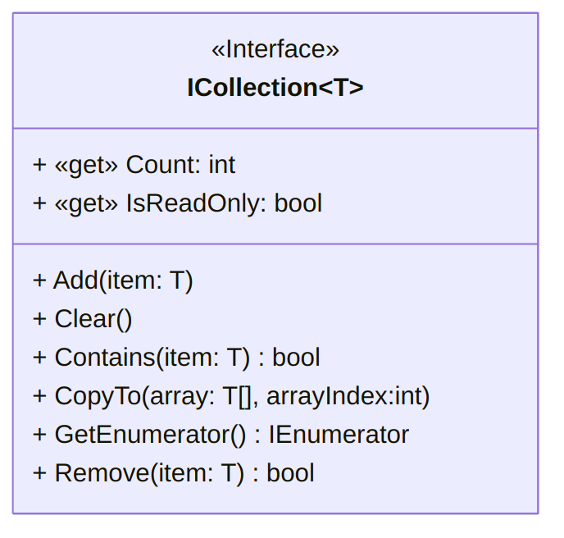

A UML diagram for the ICollectionT class ([text version](https:/princomp.github.io/diag/cla/ICollection.txt), [image version](https:/princomp.github.io/diag/cla/ICollection.png), [svg version](https:/princomp.github.io/diag/cla/ICollection.svg))

This requires implementing a series of properties and methods:

// Empty  
 public bool IsEmpty()  
 {  
 return first == null;  
 }  
  
 // Add is simply "AddF", slightly revisited.  
 public void Add(T value)  
 {  
 if (isReadonly)  
 {  
 throw new InvalidOperationException(  
 "List is read-only."  
 );  
 }  
 Cell cCell = first;  
 if (cCell != null)  
 {  
 while (cCell.Next != null)  
 // As long as the cCell Cell has a neighbour…  
 {  
 cCell = cCell.Next;  
 // We move the cCell cell to this neighbour.  
 }  
 cCell.Next = new Cell(value, null);  
 }  
 else  
 {  
 first = new Cell(value, null);  
 }  
 }  
  
 public void Clear()  
 {  
 first = null;  
 }  
  
 public bool Contains(T value)  
 {  
 bool found = false;  
 Cell cCell = first;  
 while (cCell != null && !found)  
 {  
 if (cCell.Data.Equals(value))  
 {  
 found = true;  
 }  
 cCell = cCell.Next;  
 }  
 return found;  
 }  
  
 // Copies the elements of the ICollection to an Array, starting at a particular Array index.  
 public void CopyTo(T[] array, int arrayIndex)  
 {  
 if (array == null)  
 throw new ArgumentNullException(  
 "The array cannot be null."  
 );  
 if (arrayIndex < 0)  
 throw new ArgumentOutOfRangeException(  
 "The starting array index cannot be negative."  
 );  
 if (Count > array.Length - arrayIndex)  
 throw new ArgumentException(  
 "The destination array has fewer elements than the collection."  
 );  
  
 Cell cCell = first;  
 int i = 0; // keeping track of how many elements were copied.  
 while (cCell != null)  
 {  
 array[i + arrayIndex] = cCell.Data;  
 i++;  
 cCell = cCell.Next;  
 }  
 }  
  
 public bool Remove(T value)  
 {  
 if (isReadonly)  
 {  
 throw new InvalidOperationException(  
 "List is read-only"  
 );  
 }  
 bool removed = false;  
 if (!IsEmpty())  
 {  
 if (first.Data.Equals(value))  
 {  
 first = first.Next;  
 removed = true;  
 }  
 else  
 {  
 Cell cCell = first;  
 while (cCell.Next != null)  
 {  
 if (cCell.Next.Data.Equals(value))  
 {  
 cCell.Next = cCell.Next.Next;  
 removed = true;  
 }  
 }  
 }  
 }  
 return removed;  
 }  
  
 public int Count  
 {  
 get  
 {  
 int size = 0;  
 Cell cCell = first;  
 while (cCell != null)  
 {  
 cCell = cCell.Next;  
 size++;  
 }  
 return size;  
 }  
 }  
  
 public bool isReadonly = false;  
 public bool IsReadOnly  
 {  
 get { return isReadonly; }  
 set { isReadonly = value; }  
 }  
  
 public IEnumerator<T> GetEnumerator()  
 {  
 Cell cCell = first;  
 while (cCell != null)  
 {  
 yield return cCell.Data;  
 cCell = cCell.Next;  
 }  
 }  
  
 IEnumerator IEnumerable.GetEnumerator()  
 {  
 return this.GetEnumerator(); // call the generic version of the method  
 }

[*(Download this code)*](https:/princomp.github.io/code/projects/CList_ICollection.zip)