2025-10-07

# AVL trees

## Introduction

An [AVL tree](https://en.wikipedia.org/wiki/AVL_tree) (for **A**delson-**V**elsky and **L**andis, their two inventors) is a particular type of binary search tree, with the *self-balancing* property. In a nutshell, self-balancing trees always thrive to keep their height as small as possible when inserting and deleting values.

Indeed, consider a binary search tree using the Insert method defined previously to insert the values 1, 2, 3, …, 100 (in that order). Then we obtain a tree that is a line, with each node having at most 1 child.

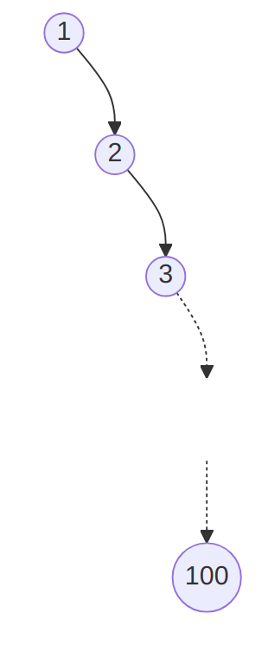

The binary search tree obtained by inserting 1, 2, …, 100 (in that order). ([text version](https:/princomp.github.io/diag/gra/bstree_example_6.txt), [image version](https:/princomp.github.io/diag/gra/bstree_example_6.png), [svg version](https:/princomp.github.io/diag/gra/bstree_example_6.svg))

The resulting tree has for height the number of nodes, 100 in this case. Since looking up a value or inserting a value is linear in the height of the tree, this means that those operations takes 100 operations: the benefits of using a tree instead of a list is lost!

The resulting tree would be much more efficient if we were leveraging the property of binary search tree to “balance” the values and obtain something … more balanced, with a “maximal number of children” for each nodes.

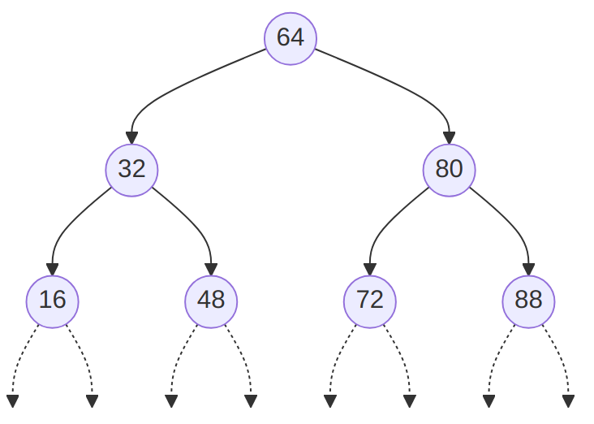

A balanced binary search tree containing 1, 2, …, 100. ([text version](https:/princomp.github.io/diag/gra/bstree_example_7.txt), [image version](https:/princomp.github.io/diag/gra/bstree_example_7.png), [svg version](https:/princomp.github.io/diag/gra/bstree_example_7.svg))

This is precisely the point of AVL trees, which are binary search trees with the additional property:

The heights of the two child subtrees of any node differ by at most one; if at any time they differ by more than one, re-balancing is done to restore this property.

where

* the *height* of a node is the number of edges on the longest path from the node to a leaf.
* the *depth* of a node is the number of edges from the node to the tree’s root node.

A good way of [remembering the difference](https://stackoverflow.com/q/2603692) is to observe that we measure the height of a person from toe (leaf) to head (root), while we measure the depth (of an ocean) from earth’s surface (root) to ocean bed (leaf).

## Possible Implementation

The main challenge is to “re-balance” the tree when needed. To determine if a tree needs to be re-balanced, one has to compute its “balance factor”, obtained by substracting the right subtree height from the left subtree height. This is done below in the SubtreeBalance method.

Consider the following:

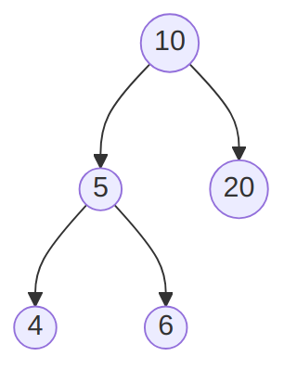

An almost unbalanced binary search tree ([text version](https:/princomp.github.io/diag/gra/bstree_example_8.txt), [image version](https:/princomp.github.io/diag/gra/bstree_example_8.png), [svg version](https:/princomp.github.io/diag/gra/bstree_example_8.svg))

After inserting 2, the tree becomes:

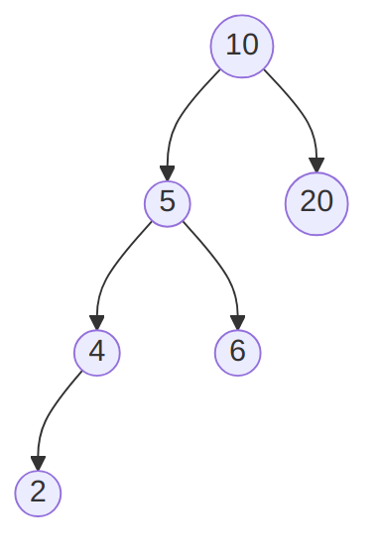

A left-left heavy binary search tree ([text version](https:/princomp.github.io/diag/gra/bstree_example_10.txt), [image version](https:/princomp.github.io/diag/gra/bstree_example_10.png), [svg version](https:/princomp.github.io/diag/gra/bstree_example_10.svg))

which needs to be re-balanced using the RotateleftChild method given below. Indeed it is “left-heavy”, on the left-hand side (because the left sub-tree, with root 5, is deeper, because of its left side).

If, re-using the same example, we insert 7, then the tree becomes:

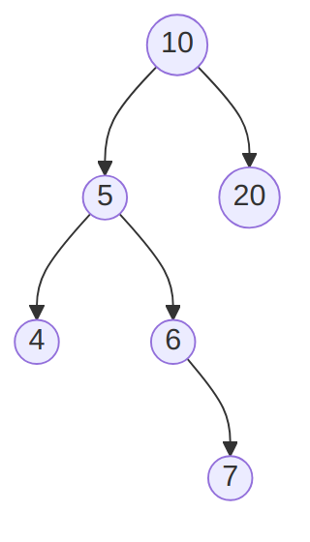

A left-right heavy binary search tree ([text version](https:/princomp.github.io/diag/gra/bstree_example_9.txt), [image version](https:/princomp.github.io/diag/gra/bstree_example_9.png), [svg version](https:/princomp.github.io/diag/gra/bstree_example_9.svg))

which needs to be re-balanced using the Doubleleftchild method given below. Indeed it is “left-heavy”, on the right-hand side (because the left sub-tree, with root 5, is deeper, because of its right side).

### Storing the height in the node

using System;  
using System.Collections.Generic;  
  
public class AVLTree<T>  
 where T : IComparable<T>  
{  
 private class Node  
 {  
 public T Data { get; set; }  
 public Node left;  
 public Node right;  
 private int height;  
 public int Height  
 {  
 get { return height; }  
 set  
 {  
 if (value >= 0)  
 height = value;  
 else  
 throw new ApplicationException(  
 "TreeNode height can't be < 0"  
 );  
 }  
 }  
  
 public Node(  
 T dataP = default(T),  
 Node leftP = null,  
 Node rightP = null,  
 int heightP = 0  
 )  
 {  
 Data = dataP;  
 left = leftP;  
 right = rightP;  
 Height = heightP;  
 }  
  
 public override string ToString()  
 {  
 return Data.ToString();  
 }  
 }  
  
 private Node root;  
  
 public AVLTree()  
 {  
 root = null;  
 }  
  
 public void Clear()  
 {  
 root = null;  
 }  
  
 public T FindMin()  
 {  
 if (root == null)  
 throw new ApplicationException(  
 "FindMin called on empty BinSearchTree"  
 );  
 else  
 return FindMin(root);  
 }  
  
 private T FindMin(Node nodeP)  
 {  
 if (nodeP.left == null)  
 return nodeP.Data;  
 else  
 return FindMin(nodeP.left);  
 }  
  
 private int GetHeight(Node nodeP)  
 {  
 if (nodeP == null)  
 return -1;  
 else  
 return nodeP.Height;  
 }  
  
 // We have a method to update the height  
 // of a node, and of its sub-trees.  
 private int UpdateHeight(Node nodeP)  
 {  
 int height = -1;  
 if (nodeP != null)  
 {  
 int nodeLeft = UpdateHeight(nodeP.left);  
 int nodeRight = UpdateHeight(nodeP.right);  
 height = Math.Max(nodeLeft, nodeRight) + 1;  
 nodeP.Height = height;  
 }  
 return height;  
 }  
  
 // The following will return  
 // a negative number if subtree is right-heavy  
 // a positive number if subtree is left-heavy  
 // 0 if the subtree is perfectly balanced.  
 // The AVL tree will need to be re-balanced if the value  
 // returned is greater than or equal to 2, or  
 // less than or equal to -2.  
 // Stated differently, if the value returned is  
 // -1, 0 or 1, then no re-balancing will take place.  
 private int SubtreeBalance(Node nodeP)  
 {  
 UpdateHeight(nodeP.left);  
 UpdateHeight(nodeP.right);  
 int balance;  
 if (nodeP == null)  
 {  
 balance = 0;  
 }  
 else if (nodeP.left == null && nodeP.right == null)  
 {  
 balance = 0;  
 }  
 else if (nodeP.left == null)  
 {  
 balance = -(nodeP.right.Height + 1);  
 }  
 else if (nodeP.right == null)  
 {  
 balance = nodeP.left.Height + 1;  
 }  
 else  
 {  
 balance = nodeP.left.Height - nodeP.right.Height;  
 }  
 return balance;  
 }  
  
 public void Insert(T valueP)  
 {  
 root = Insert(valueP, root);  
 }  
  
 /*  
 * Before  
 * nodeTop --> A  
 * / \  
 * nodeLeft--> B C  
 * / \  
 * D E <-- nodeLeft.right  
 *  
 * After  
 * B  
 * / \  
 * D A  
 * / \  
 * E C  
 */  
 private Node RotateleftChild(Node nodeTop) // Aka left-left rotation  
 {  
 Node nodeLeft = nodeTop.left;  
 nodeTop.left = nodeLeft.right;  
 nodeLeft.right = nodeTop;  
  
 // update heights  
 nodeTop.Height =  
 Math.Max(  
 GetHeight(nodeTop.left),  
 GetHeight(nodeTop.right)  
 ) + 1;  
 nodeLeft.Height =  
 Math.Max(GetHeight(nodeLeft.left), GetHeight(nodeTop))  
 + 1;  
  
 return nodeLeft; // attached to caller as the new top of this subtree  
 }  
  
 /*  
 * Before  
 * nodeTop --> A  
 * / \  
 * B C <-- nodeRight  
 * / \  
 * D E  
 *  
 * After  
 * C  
 * / \  
 * A E  
 * / \  
 * B D  
 */  
 private Node RotaterightChild(Node nodeTop) // Aka right-right rotation  
 {  
 Node nodeRight = nodeTop.right;  
 nodeTop.right = nodeRight.left;  
 nodeRight.left = nodeTop;  
  
 // update heights  
 nodeTop.Height =  
 Math.Max(  
 GetHeight(nodeTop.left),  
 GetHeight(nodeTop.right)  
 ) + 1;  
 nodeRight.Height =  
 Math.Max(  
 GetHeight(nodeRight.left),  
 GetHeight(nodeTop)  
 ) + 1;  
  
 return nodeRight; // attached to caller as the new top of this subtree  
 }  
  
 /*  
* Before  
* nodeP --> A  
* / \  
* B C  
* / \ / \  
* D E F G  
*  
* After RotaterightChild  
* A  
* / \  
* E C  
* / / \  
* B F G  
* /  
* D  
*  
* After  
* E  
* / \  
* B A  
* / \  
* D C  
* / \  
* F G  
*  
* The simplified version is:  
* Before:  
* A  
* /  
* B  
* \  
* E  
* After:  
* E  
* / \  
* B A  
*/  
  
 private Node DoubleleftChild(Node nodeP)  
 {  
 nodeP.left = RotaterightChild(nodeP.left);  
 return RotateleftChild(nodeP);  
 }  
  
 private Node DoublerightChild(Node nodeP)  
 {  
 nodeP.right = RotateleftChild(nodeP.right);  
 return RotaterightChild(nodeP);  
 }  
  
 private Node Insert(T valueP, Node nodeP)  
 {  
 if (nodeP == null)  
 return new Node(valueP, null, null, 0);  
 else if (valueP.CompareTo(nodeP.Data) < 0) // valueP < nodeP.Data --> go left  
 {  
 nodeP.left = Insert(valueP, nodeP.left);  
 if (  
 (GetHeight(nodeP.left) - GetHeight(nodeP.right))  
 == 2  
 )  
 {  
 if (valueP.CompareTo(nodeP.left.Data) < 0)  
 {  
 nodeP = RotateleftChild(nodeP);  
 }  
 else  
 {  
 nodeP = DoubleleftChild(nodeP);  
 }  
 }  
 }  
 else if (valueP.CompareTo(nodeP.Data) > 0) // valueP > nodeP.Data --> go right  
 {  
 nodeP.right = Insert(valueP, nodeP.right);  
 if (  
 (GetHeight(nodeP.right) - GetHeight(nodeP.left))  
 == 2  
 )  
 {  
 if (valueP.CompareTo(nodeP.right.Data) > 0)  
 {  
 nodeP = RotaterightChild(nodeP);  
 }  
 else  
 {  
 nodeP = DoublerightChild(nodeP);  
 }  
 }  
 }  
 else // valueP == nodeP.Data  
 {  
 throw new ApplicationException(  
 "Tree did not insert "  
 + valueP  
 + " since an item with that value is already in the tree."  
 );  
 }  
  
 nodeP.Height =  
 Math.Max(  
 GetHeight(nodeP.left),  
 GetHeight(nodeP.right)  
 ) + 1;  
 return nodeP;  
 }  
  
 public int Depth()  
 {  
 int depth = 0;  
 if (root != null)  
 {  
 depth = Depth(root, 0);  
 }  
 return depth;  
 }  
  
 private int Depth(Node nodeP, int depth)  
 {  
 // "Unless proven otherwise",  
 // we assume that the depth of the  
 // node is the depth it received  
 // as argument.  
 int result = depth;  
 // We assume the depth of  
 // its right sub-tree  
 // is 0.  
 int depthL = 0;  
 if (nodeP.left != null)  
 {  
 // If its left sub-tree is not null,  
 // we inquire about its depth,  
 // knowing that it will be 1 more  
 // than the depth of the current node.  
 depthL = Depth(nodeP.left, result + 1);  
 }  
 // We proceed similarly for the  
 // left sub-tree.  
 int depthR = 0;  
 if (nodeP.right != null)  
 {  
 depthR = Depth(nodeP.right, result + 1);  
 }  
 // Finally, if at least one sub-tree  
 // is not null, we take the max of their  
 // depths to be the depth of the tree  
 // starting with our current node.  
 if (nodeP.left != null || nodeP.right != null)  
 {  
 result = Math.Max(depthL, depthR);  
 }  
 return result;  
 }  
  
 public bool Remove(T value)  
 {  
 return Remove(value, ref root);  
 }  
  
 private bool Remove(T value, ref Node nodeP)  
 {  
 bool found = false;  
 if (nodeP != null)  
 {  
 if (value.CompareTo(nodeP.Data) < 0) // value < nodeP.Data, check left subtree  
 {  
 found = Remove(value, ref nodeP.left); // similar to BST's find and remove method  
 if (SubtreeBalance(nodeP) <= -2) // negative balance means heavy on right side  
 {  
 if (SubtreeBalance(nodeP.right) <= 0) // children in straight line  
 nodeP = RotaterightChild(nodeP); // rotate middle up to balance  
 else  
 nodeP = DoublerightChild(nodeP); // children in zig patter - needs double rotate to balance  
 }  
 }  
 else if (value.CompareTo(nodeP.Data) > 0) // value > nodeP.Data, check right subtree  
 {  
 found = Remove(value, ref nodeP.right);  
 if (SubtreeBalance(nodeP) >= 2)  
 {  
 if (SubtreeBalance(nodeP.left) >= 0)  
 nodeP = RotateleftChild(nodeP);  
 else  
 nodeP = DoubleleftChild(nodeP);  
 }  
 }  
 else // The value was found!  
 {  
 found = true;  
 if (nodeP.left != null && nodeP.right != null) // Two children  
 {  
 nodeP.Data = FindMin(nodeP.right);  
 Remove(nodeP.Data, ref nodeP.right);  
 if (SubtreeBalance(nodeP) == 2) // Need to rebalance  
 {  
 if (SubtreeBalance(nodeP.left) >= 0)  
 nodeP = RotateleftChild(nodeP);  
 else  
 nodeP = DoubleleftChild(nodeP);  
 }  
 }  
 else  
 {  
 nodeP = nodeP.left ?? nodeP.right; // replace with one or no child  
 // This is equivalent to  
 // if (nodeP.left == null){  
 // nodeP = nodeP.right;  
 // } else { nodeP = nodeP.left;}  
 // Observe that if both are null, then nodeP simply  
 // becomes null, as expected.  
 }  
 }  
 }  
 return found;  
 }  
  
 // The ToString method is simply here to help us debug.  
 // It is not really pretty, but using pre-order and spaces  
 // to make it easier to understand how the tree is  
 // constructed. It also displays the depth of the tree  
 // and the height of the nodes.  
  
 public override string ToString()  
 {  
 string returned = "Depth: " + Depth() + "\n";  
 if (root != null)  
 {  
 returned += Stringify(root, 0);  
 }  
 return returned;  
 }  
  
 private string Stringify(Node nodeP, int depth)  
 {  
 string returned = "";  
 if (nodeP != null)  
 {  
 for (int i = 0; i < depth; i++)  
 {  
 returned += " ";  
 }  
 returned += nodeP + " (depth: " + depth + ")\n"; // Calls Node's ToString method.  
 if (nodeP.left != null)  
 {  
 returned += "L" + Stringify(nodeP.left, depth + 1);  
 }  
 if (nodeP.right != null)  
 {  
 returned += "R" + Stringify(nodeP.right, depth + 1);  
 }  
 }  
 return returned;  
 }  
}

[*(Download this code)*](https:/princomp.github.io/code/projects/AVLTree.zip)

### Computing the height on the fly

It is also possible to compute the height of nodes “on the fly” instead of storing it. [This archive](https:/princomp.github.io/code/projects/AVLTree_I.zip) demonstrates this concept while additionally inheriting from the BTree class [explored previously](https:/princomp.github.io/lectures/data/trees).