2025-09-30

Trees
Solutions for those exercises.

Exercises
- Consider the following tree:
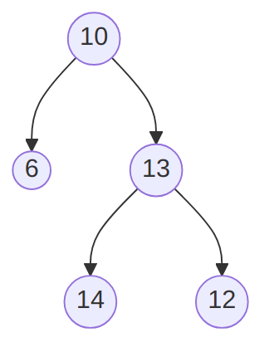
A binary tree that is not a binary search tree. (text version, image version, svg version)
  - Explain why it is not a binary search tree.
  - Pick one among inorder, preorder and postorder traversal, and give
    - A brief description of how it proceeds,
    - What it would produce for the given tree.
- Consider the following implementation of “random” binary trees:
public class RBTree<T>
{

private class Node
{
public T Data { get; set; }
public Node left;
public Node right;
public Node(
T dataP = default(T),
Node leftP = null,
Node rightP = null
)
{
Data = dataP;
left = leftP;
right = rightP;
}
}

private Node root;

public RBTree()
{
root = null;
}

public void Insert(T dataP)
{
root = Insert(dataP, root);
}

private Node Insert(T dataP, Node nodeP)
{
if (nodeP == null)
{
return new Node(dataP, null, null);
}
else
{
Random gen = new Random();
if(gen.NextDouble() > 0.5)
{
nodeP.left = Insert(dataP, nodeP.left);
}
else
{
nodeP.right = Insert(dataP, nodeP.right);
}
}
return nodeP;
}
}
Note that the Insert(T dataP, Node nodeP) method uses the gen.NextDouble() > 0.5 test that will be randomly true half of the time, and false the other half.
  - Explain the T dataP = default(T) part of the Node constructor.
  - Write a ToString method for the Node class, remembering that only a node Data needs to be part of the string returned.
  - Write a series of statements that would
    - create a RBTree object,
    - insert the values 1, 2, 3, and 4 in it (in this order).
  - Make a drawing of a possible RBTree obtained by executing your code.
  - Write a Find method that takes one argument dataP of type T and returns true if dataP is in the RBtree calling object, false otherwise.

